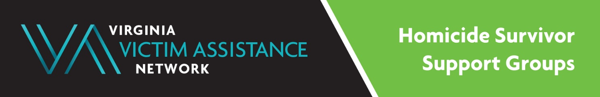
Purpose: Homicide Survivor Support Groups (HSGs) are intended to promote healing and to create a supportive network for Virginia residents who are close friends or family members of someone who lost their life due to homicide.
When: Monthly, weekly, and bi-weekly, depending upon location.
Locations: Meetings are free, virtual, and in-person.

Program Contact: Scharnelle Hamlin, HSG Coordinator at 804-331-4057 x 103 or
Scharnelle.Hamlin@vanetwork.org

Contacts for Support Groups:

City of Chesapeake: Patty Strathmann, 757-382-6794 (Adult Group) pstrathm@CityOfChesapeake.Net

City of Hampton: Tyrone George, 757-726-5417 (Adult Group)
Anthony.george@hampton.gov

Henrico County: Scharnelle Hamlin, 804-331-4057 x 103 (Adult Group)
Scharnelle.Hamlin@vanetwork.org

Hopewell/Tri- cities: Angela Crockett, 804-541-2352 (Adult Group)
acrockett@hopewellva.gov

City of Newport News: Casey Hearne, 757-926-7257 (Adult Group) or email
Scharnelle.Hamlin@vanetwork.org or hearnecb@nnva.gov

Lee County: Donna Kolb or Amy Taylor, (276) 346-2689 (Adult Group)
ddkolb@leecova.org or ataylor@leecova.org

Northern Virginia/Fairfax: Scharnelle Hamlin, 804-331-4057 x103 (Adult Group)
Scharnelle.Hamlin@vanetwork.org

Petersburg: Scharnelle Hamlin 804-331-4057 x103 (Adult Group)
Scharnelle.Hamlin@vanetwork.org

Portsmouth: Tanishia Hinton, 757-393-8581 X 7040 (Adult Group)
Tanisha.Hinton@Portsmouthva.gov

Roanoke Region- Carilion Grief and Healing Center: Scharnelle Hamlin 804-331-4057 x103 (Adult Group)
Scharnelle.Hamlin@vanetwork.org

Spanish Speaking Bi-lingual Grief Group: RVADueloLatino@gmail.com managed by Legacy Hospice of Richmond: Two groups (10am and 6pm) on the last Tuesday of the month.

VVAN Statewide Virtual Group: Scharnelle Hamlin, 804-331-4057 x103 (Adult Group)
Scharnelle.Hamlin@vanetwork.org

(Includes any area of the state of Virginia, however, survivors not attending other HSG groups already, may receive priority consideration). Thank you.
*** The City of Richmond Victim/Witness Program hosts a monthly English-Speaking Adult Group. Please call 804-646-7665.
*** The City of Danville hosts an English-Speaking Group, Captain David E. Whitley
Homicide Support Coordinator, 434-799-6508

This project is supported by a VOCA Victim Services Grant from the Virginia Department of Criminal Justice Services, and from local funders LEPCO, the SEAY Foundation and the Cameron Foundation.
Thank you.

