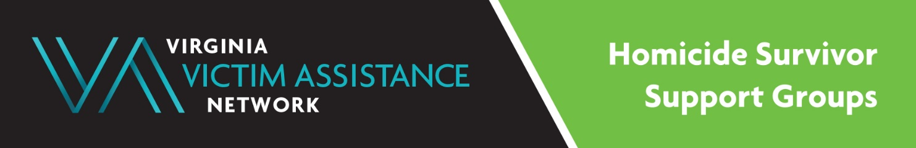
Purpose: Homicide Survivor Support Groups (HSGs) are intended to promote healing and to create a supportive network for Virginia residents who are close friends or family members of someone who lost their life due to homicide.
When: Monthly, weekly, and bi-weekly, depending upon location.
Locations: Meetings are virtual and in-person.

Program Contact: Dina Blythe, HSG Coordinator at 804-331-4057 x 103 or dina.blythe@vanetwork.org

Locations and Contacts for Support Groups:

Appomattox County: MaryAnne Freshwater, 434-352-7791 (Adult Group) maryanne.freshwater@appomattoxcountyva.gov

City of Chesapeake: Patty Strathmann, 757-382-6794 (Adult Group) pstrathm@CityOfChesapeake.Net

City of Hampton: Tyrone George, 757-726-5417 (Adult Group)
Anthony.george@hampton.gov

Henrico County: Dina Blythe, 804-331-4057 x 103 (Adult Group)
dina.blythe@vanetwork.org

City of Newport News: Malik Brice, 757-926-7257 (Adult Group) or email
dina.blythe@vanetwork.org or bricema@nnva.gov

The International Rescue Committee: Dina Blythe, 804-331-4057 x 103 (Adult Group, TBD)
dina.blythe@vanetwork.org

Lee County: Donna Kolb or Amy Taylor, (276) 346-2689 (Adult Group)
ddkolb@leecova.org or ataylor@leecova.org

Northern Virginia/Fairfax: Dina Blythe 804-331-4057 x103 (Adult Group)
dina.blythe@vanetwork.org

Virginia Beach Group: Dina Blythe, 804-331-4047 x 103 (Adult Group)
dina.blythe@vanetwork.org

VVAN Statewide Virtual Group: Dina Blythe, 804-331-4057 x103 (Adult Group)
dina.blythe@vanetwork.org
(Includes any area of the state of Virginia, however, survivors not attending other HSG groups already, may receive priority consideration). Thank you.
*** The City of Richmond Victim/Witness Program hosts a monthly English-Speaking Adult Group. Please call 804-646-7665.
This project is supported by a VOCA Victim Services Grant from the Virginia Department of Criminal Justice Services.
Thank you.

